**LAB MANUAL # 07**

**GRAPHIC USER INTERFACE**

**Objective:**

The objective of this lab is to practice GUI in MATLAB using Guide.

**Description:**

You have to design a GUI using guide in MATLAB. A demo video has been uploaded with manual for your understanding.

## **LAB TASK:**

## **Task # 01:**

Design a GUI for a calculator and add following operation in the calculator:

* ADD
* SUBTRACT
* MULTIPLAY
* DIVIDE

Submit a video in which you should show all the operation in running form.

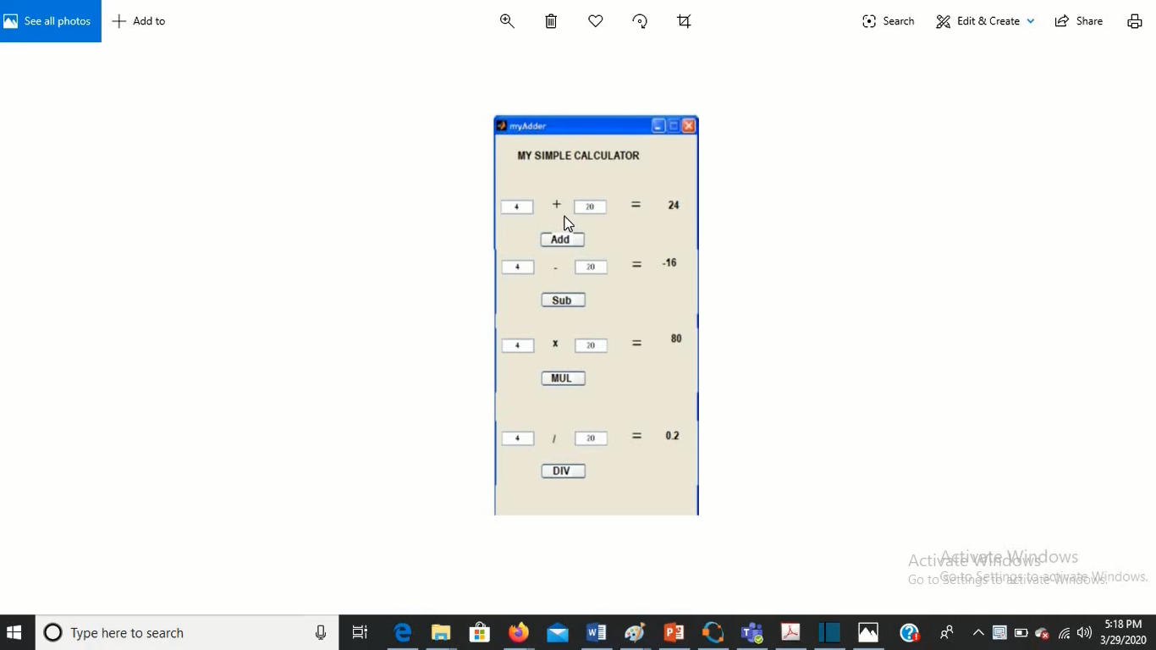

Figure : Sample GUI Design